HPTS-working protocol

Monday, October 29, 2018

1630

To a 50-mL beaker add:

5 mg Cholesterol (dissolve into chloroform solution of POPC) (100 uL)

200 ul 25 mg/mL POPC (5 mg)---vortex

10 uL 1 mg/mL Rho-DPPE (~0.25 mol%)----vortex

Add 1 ml mineral oil----vortex

Heat at 80C for 15 min (vortex)

Cool oil for 5 min on the bench (paper-covered bench)

Im

a

of

i

d

lp

~~n~~

mixtur

e

after

cooling

3

650

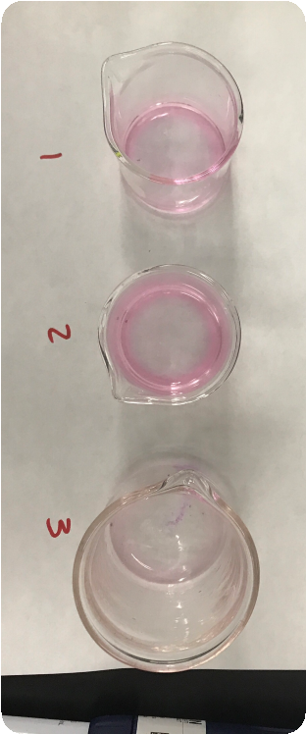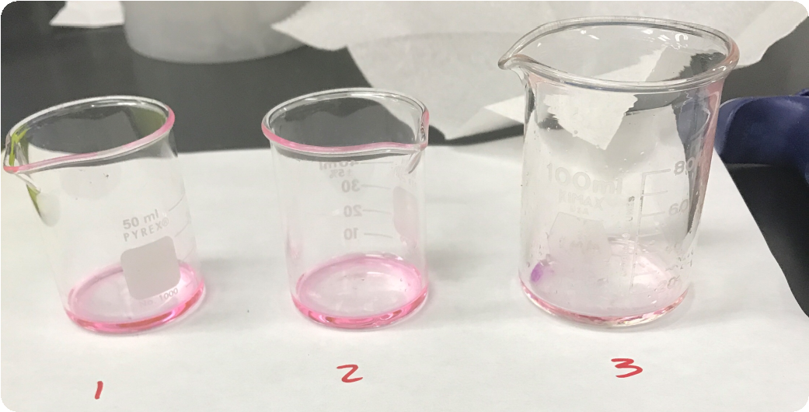

Images of lipid and oil mixture after

cooking

Incubate the following in a microfuge-tube rack for 10 min at 4C:

150 uL of lipid/oil on top of 225 uL outer solution

2 tubes of 225 uL of outer solution

1 tube 400 uL of outer solution (based on how much you resuspend in)

20 uL inner solution (1 ul HTPS (40 uM) and 19 uL inner solution)

500 uL of lipid/oil

Cool centrifuge to 4C

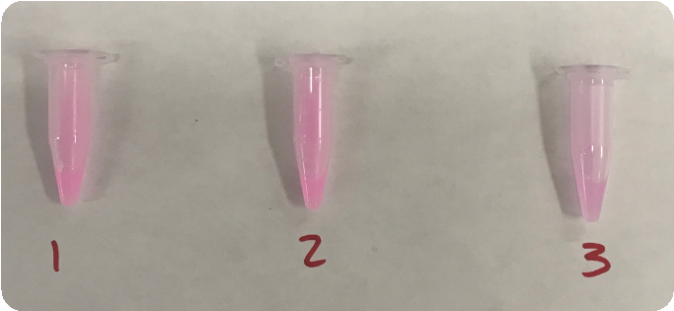To 500 uL of 4C lipid/oil mixture

add 20 uL inner solution (1.5 ul HTPS and 28.5 uL inner solution)

# Pulse using a vortex, vortex for 2 minutes

dispersion appears complete

No droplet visible on the bottom

Keep on ice while not handling

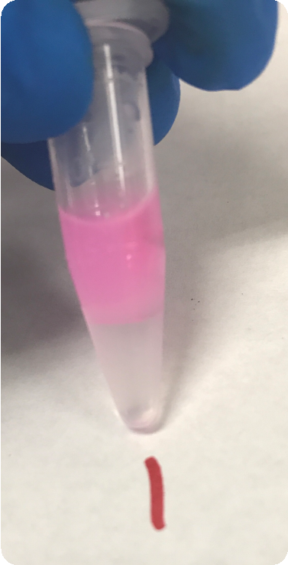

Layer over the 225 uL cold outer solution (200 mM glucose, 100 mM HEPES pH :sunglasses: that was preincubated with 150 uL cold lipid/oil

Centrifuge immediately at 14000 g for 10 min at 4C

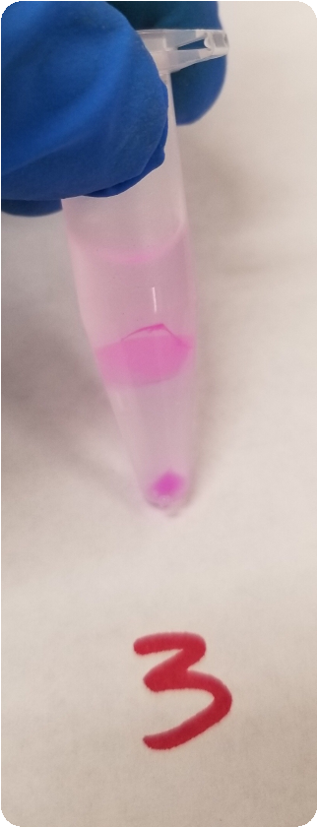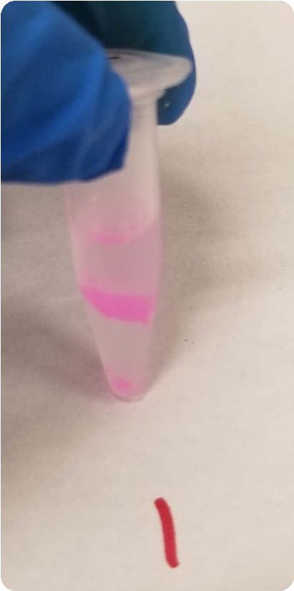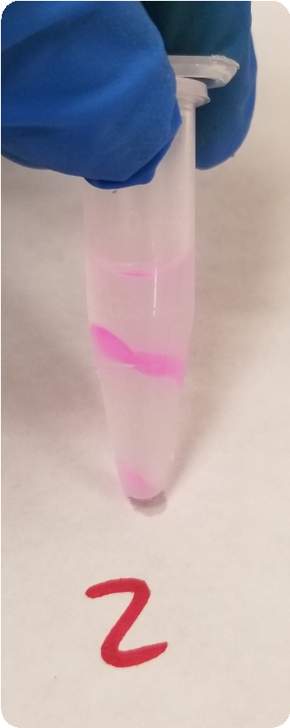

Carefully remove the oil layer with 1-mL tip and finally as much as possible with a gel loading tip

Transfer the pellet into another 225 mL outer solution using a 1 mL pipette tip

~~Mix by pipetting up and down using 1 mL pipette tip~~

Centrifuge at 9000 g for 5 min at 4C

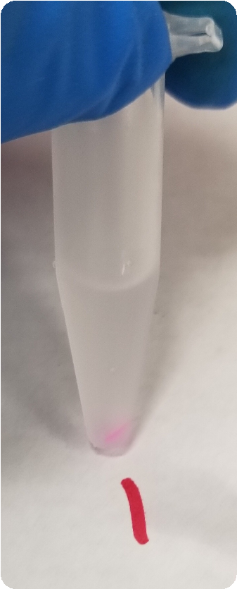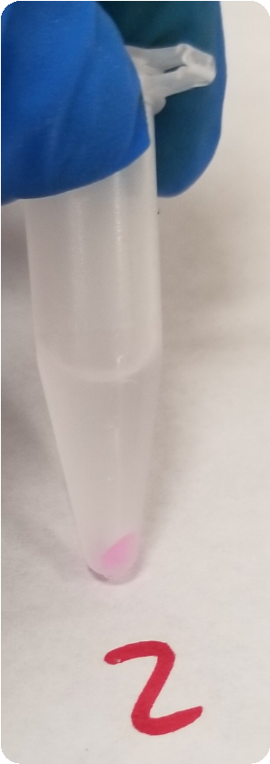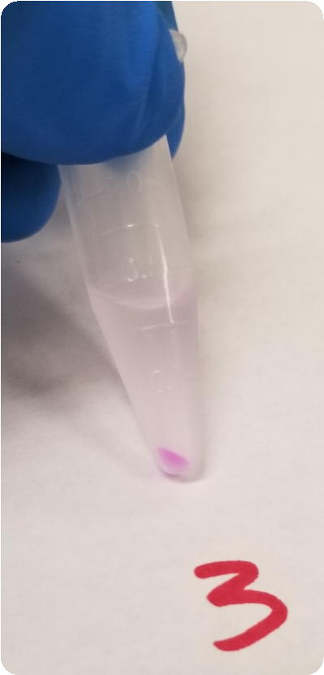

Carefully remove the oil layer with 1-mL tip and finally as much as possible with a gel loading tip

Transfer the pellet into another 225 uL outer solution using a 1 mL pipette tip

Mix by pipetting up and down using a 1 mL pipette tip

Centrifuge at 9000 g for 5 min at 4C

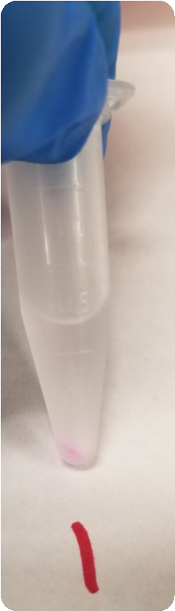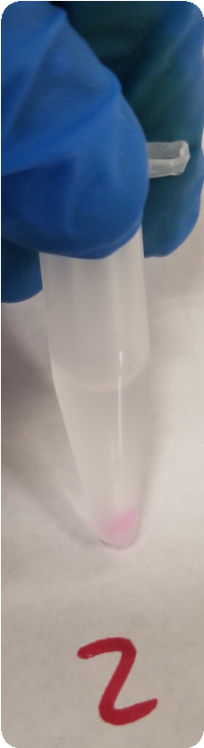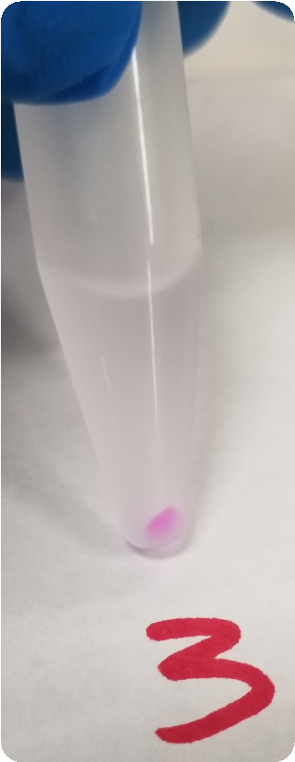

Transfer the pellet into 400 uL outer solution using a 1 mL pipette tip

Mix by pipetting up and down using a clean 1 mL pipette tip

Right

micro

cent

~~r~~

ifuge

tube

is

H2o

for

rity

~~a~~

cl

~~n~~

~~o~~

is

~~r~~

mp

~~o~~

c

~~a~~

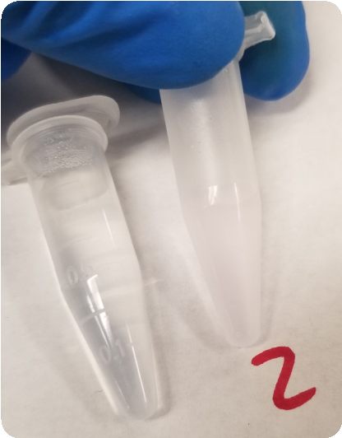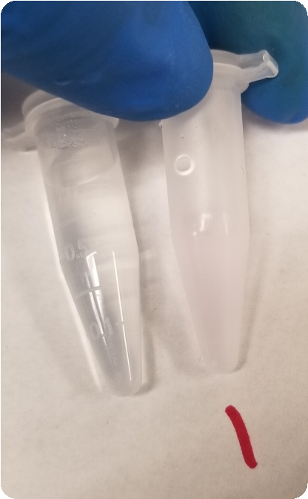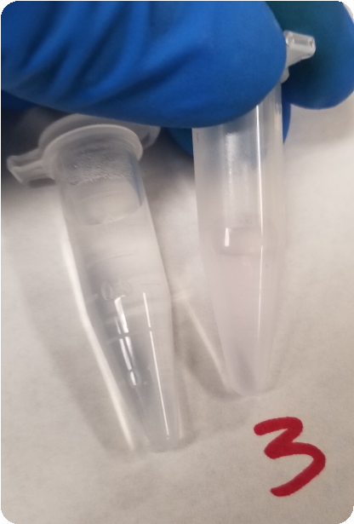

Place 9 uL on a ~~poly-l-lysin~~e ~~coated~~ slide topped with a 0.12 mm spacer

Do Microscopy as soon as possible (within minutes)

Cha

~~n~~

~~n~~

~~e~~

y

ls

BF

GFP

RFP

N

E

G

N

I

e

E

~~E~~

S

